# Table of contents

Table of contents 1

1. People involved in the application 2

1.1 Executive officer 2

1.2 Lecture head 2

1.3 Lecturer 2

1.4 Students in android 2

1.5 People leader 3

2. List of processes involved 3

2.1 Approval process for addition and modification 4

2.2 Approval process for the deletion of the video 5

3. Screens 6

3.1 Website 6

3.1.1 For EO (Executive officer) 6

3.1.2 For Lecture head 7

3.1.3 For lecturer 8

3.1.4 For People leader 8

3.1.5 For Android students 8

3.2 Android 9

3.2.1 Registration 9

3.2.2 Category screen 9

3.2.3 Question answer with video selected 10

3.2.4 Result screen 10

3.2.5 Summary screen 11

3.2.6 Background task 11

4. Application security, scalability 11

4.1 Security: 11

4.2 Scalability 11

5. Maintainence and enhancement plan 12

# 1. People involved in the application

Executive officer

Lecturer head

Lecturer

Android Students

People Leader

## 1.1 Executive officer

Will be responsible to approve addition, modification and deletion of the videos.

The video’s can be created by

* Lecture head
* Lecturer

## 1.2 Lecture head

Lecture head will collect details from the lecturer. After his approval, the material goes to the approval of the Executive officer. Once the executive officer approves the material, the material would then appear in the list of videos to be viewed by the students in the android

## 1.3 Lecturer

Lecturer also has a login. In this login he can also upload the video content. Lecturer can save the content for sending to approval to the lecturer head. Once the lecture content is complete, the content is sent for approval to the lecture head. If the lecturer head modifies the content, the material modified by the lecturer head is presented to the lecturer. Once the

## 1.4 Students in android

Students in android can view the existing categories and videos.

Students can also search the videos of their choice

When the students are searching the video, the videos are just listed with 2 columns

Video thumbnail | Video description | credits

## 1.5 People leader

People leader will be responsible for educating the Android app to the students. There can be many people leaders. People leader also has token number being generated.

Purpose of the token is to identify a

* unique token id
* unique id for the people leader.

Executive officer should be able to see, which people leader promoted many students as a part of the statistics.

# 2. List of processes involved

* Approval process for the addition/modification of the videos
* Approval process for the deletion of the videos
* Android student registering the product (this is explained in the registration screen).
  + Including token registration, reference number.

## 2.1 Approval process for addition and modification

Lecture content -> lecturer -> lecturer head -> Executive officer

The lecture content can be modified either by lecturer or lecture head, but the modifications has to be approved by both. After approval from both, the final modification has to be sent to the Executive officer.

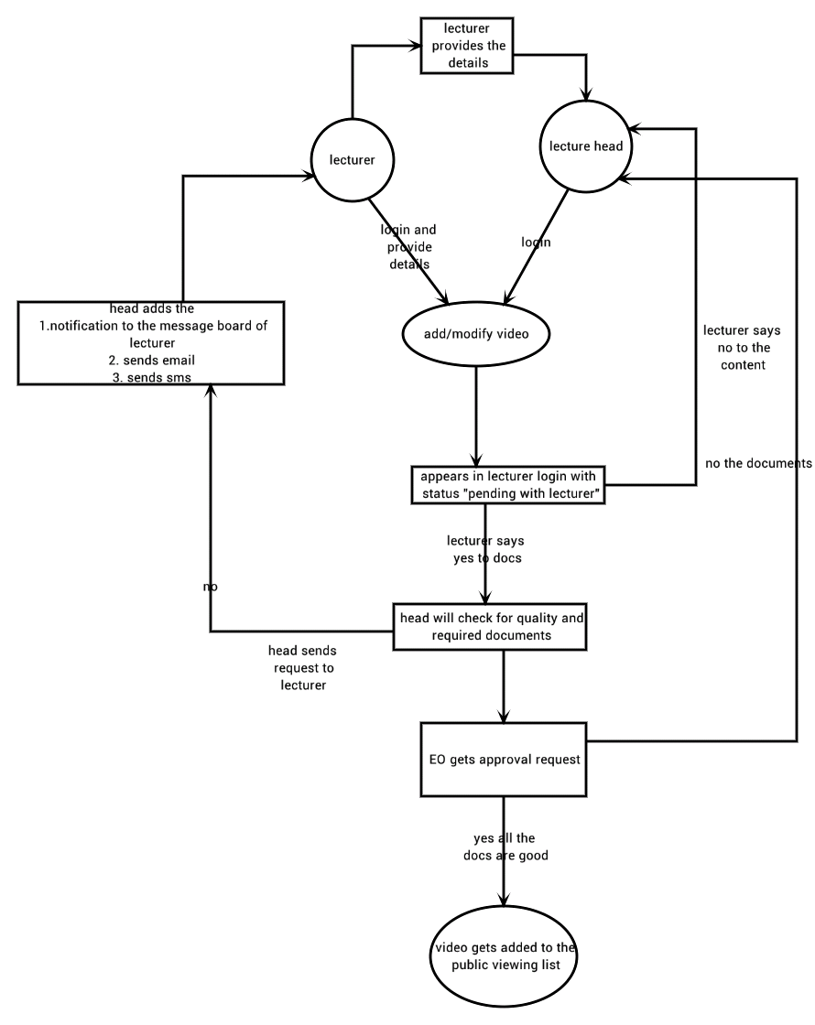

## 2.2 Approval process for the deletion of the video

* Lecturer deletes the video
* The lecturer submit the reason for deleting the video
* The video will not appear in the student video list
* The video should not be deleted in the database but marked for deletion.
* The notification is sent to
  + Lecture head
  + Executive officer
* This appears as a work item in the lecture head work list
* The lecture head will collect details for the reason for the deletion
  + Submits or uploads the scanned copy of the same.
  + Now the notification request is sent to executive officer
* The executive officer will now approve after further verification of the same.

# 3. Screens

## 3.1 Website

### 3.1.1 For EO (Executive officer)

* Should be with provision to do below details
  + see what videos are pending for approval.
  + see all the videos
  + search a video with tag
  + stop video from appearing.
    - Notification should be sent to lecture head and lecturer, about the reason of stopping the video in the listing.
  + Select a particular video and see the statistics as per the video
* Should be able to see statistics in descending order from most viewed to least viewed
  + Category
  + Which video
  + Most common search string
  + People leader, who educated more for the product, with help of token.
  + Should be able to see the list of tokens issued
    - Token consist of 2 parts
      * Id identifying the people leader.
      * Unique number identifying the token.
* Should have notification events
  + When the lecture head changes his password.
  + When the lecturer changes his password.
  + When the video is added and made to wait for approval from both lecturer and lecture head.
  + If the video is waiting for approval for more than configurable number of days, it should appear in red.
  + Daily Top 10 numbers of students who answered more questions correctly.
  + When a particular id of the student is coming many times in a brute force way, red notification with alert sms to the Executive officer should appear.
  + When ever there is a request to the lecture head from lecturer there should be a notification to the executive officer as well
  + When there is a delay of configurable number of days in the approval of the lecture head, the notification board should contain the message in red color. This is a high priority notification.

### For Lecture head

* Should be able to add a video
  + As part of adding a video, should be able to add supporting documents and upload the same to the web server.
    - Multiple upload options should be given,
    - Upload textbox, upload button, description of the document.
* After collecting the documents if there are any pending details before sending for approval to executive officer, the lecture head should be able to save the form.
* When the lecturer makes some modification, his application for approval has to be visible to the lecture head.
* After the video is added/modified/deleted by the lecture head, the state of the video should go to
  + Pending for approval from lecturer.
  + Followed by pending for approval by executive officer.
* Should be able to see what video’s are pending for approval at whose end.
* Should be able to sort by most recently approved to least recently approved,
* Should be able to see top 10 recently approved videos
* Should be able to see most recently modified videos and top 10 recently modified videos
* When the video is applied for deletion by the lecture head, there should be provision to attach supporting documents.
  + Reason for rejection, and any supporting documents
* Should be able to see temporarily stopped videos
  + Whose expiry date has reached (or)
  + Manually stopped with reasons.
* Notification list sent to the Executive Officer event list
  + If password is changed for the lecture head
  + If video is added/ modified/ deleted.
* The credentials (password) of the lecturer should not be visible to the lecture head.

### For lecturer

* If there is any issues with the login or password, or any other details, the lecturer should be given complaint form, email id of the executive officer in the general page of the website.
  + This should be visible in the public page, under the lecturer page.
* If lecturer is able to login and the details inside his page is with issues, he should be able to raise an issue/ticket.
  + There will be a button, will ask for issue description and submit button.
  + On Submit, the issue should be visible to the executive officer as well as lecturer head.
* Should be given login and password.
* Should be able to modify his details, and send the details for approval to the lecturer head.
* If the lecture head has modified his video or details, the request for approval has to be presented the lecturer page.
* Should be able to see all the supporting documents that he has submitted.
* Should be able to see the credits he has been allocated.
  + This can be treated as a simple number like 10,000.
* Should be able to see the expiry date of the video.
* Should be able to see the statistics of the video viewers
  + How many people tried to answer the question
  + How many passed/failed.
  + How many clicks per day.
* Maximum number of viewers based on the credits, this is equal to the credits allocated for his video
* Count of People currently viewed.

### For People leader

* Enters his magic number and his mobile number as his login details.
* Should be able to see how many numbers registered so far, with his magic number.

### For Android students

Students can enter the website with his registered phone numbers,

Student first enters his name and phone number.

To see his credits acquired.

## Android

### Registration

User should enter the below details, other than optional fields

1. name
2. phone number
3. email id (optional)
4. Reference number (optional) – reference of his fellow student
5. magic number (optional) – this is given by people leader who educate the product to the student, who is using the application.
   1. There should be a description under the magic number, which explains the details of the same.

Registration process

The student enters the phone number in the field.

Press the register button,

He gets a verification code to his mobile number.

He enters the verification code in the mobile phone.

A success message is issued and he enters the category screen.

When the expected answer is equal to the applied answer, the credit count increments in the students account.

If the user skips the mandatory fields, the login should not proceed.

The registration of the student with the phone number is compulsory.

This can be ensured by the login button is enabled only after filling mandatory fields.

### Category screen

Category screen should contain the following

1. search bar
2. categories
3. video thumbnails in each category
4. should be able to scale as per the size of the phone
5. should be scrollable horizontally for videos in category
6. should be scrollable vertically for categories
7. when the user goes to the question and answer screen for viewing the video, when he comes back from the question & answer screen the category and the position of the video should be remembered
8. The search string entered by the users should be dumped into a database in the website.
9. Most common search string should be suggested based on the text typed by the user; this will be useful while collecting statistics.
10. GPS based category, lecturers located near his area.

### Question answer with video selected

Screen can be divided into 3 parts

1. First part
   1. Category->The title
   2. Video or slides (with dots and swipe) or text (with scrollbar)
2. Second part
   1. Questions can range from 1 to n, to view other questions he can horizontally scroll, the question along with answer should be scrolled.
   2. Options can range from 2 to 4
   3. The question and options should be visible even while the video is playing and the user can select the options
3. Third part
   1. The next button should be enabled only after completion of the lesson. (To avoid skipping complete viewing of the lecture).
   2. There should be option to view the contact details of the lecturer.
   3. For each contact number displayed, the user should be able to call the phone number, this can be simplified with radio button, like select a phone number
   4. The results should be stored in the web even if it is wrong or right.
   5. There should be back button to go back to the category screen.

After the next button is pressed, the unique details of the users (such as name, phone numbers) should be sent along with the answers to the website. The webpage should store this as statistics.

If the user has answered correctly, the credit points should be stored in the user’s account.

### Result screen

This screen will list all the status of the questions from 1 to n, as pass or fail.

### Summary screen

In this screen the user can see what is his

* Current credit point
* Total credits rewarded

This screen should also contain option to send feedback to our website. With feedback text title (50 chars), detailed (300 chars) and a submit button.

### Background task

Time spent in each screen should be recorded and sent as report to the website.

The application should collect the list of all apps installed in the user’s phone, this will be useful to diagnose if any bad feedback has been provided by the particular set of user.

# 4. Application security, scalability

## 4.1 Security:

* + Since the database for approval can just be implemented as a flag, what are the security measures that have to be taken to avoid direct manipulation by the lecture head in the main database?
  + Should we do make VeriSign similar things in this one.

## 4.2 Scalability

* + What is the maximum limit to which the android users can access the application
    - All the android users should scroll up and down at the same time, at that time what is the latency in the application.

# 5. Maintainence and enhancement plan

if there is any crash in the application,

* What is the procedure for recovering the app from frequent crash
* What is the profiling tool for measuring the memory leak and memory usage
* What is the procedure for recovering the website from crashing